INDIAN FRESHER’S SALARY DASHBOARD
ABSTRACT
This project titled “Indian Freshers Salary Dashboard” focuses on analysing and visualizing salary trends, job roles, company types, and stipends offered to fresh graduates in India. The objective is to transform raw placement and salary data into an interactive and easy-to-understand dashboard using Microsoft Excel. The dashboard helps students, academic institutions, and recruiters understand fresher salary patterns across locations, industries, and roles. By using KPIs and charts, this project supports data-driven decision-making and career planning.
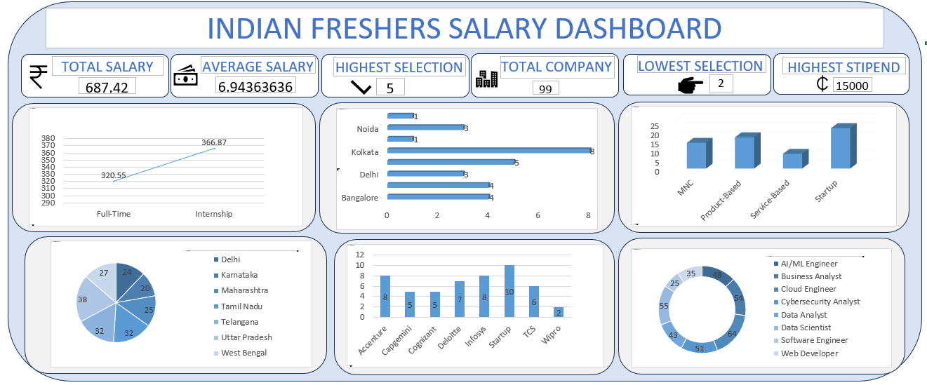
INTRODUCTION
In recent years, the Indian job market for freshers has expanded rapidly, especially in IT, analytics, and emerging technology domains. However, salary structures and opportunities vary significantly based on city, company type, and job role. Many students lack clear insights into these variations.
This project bridges that gap by:
- Collecting and organizing fresher salary data
- Analysing key metrics such as average salary, total companies, and stipends
- Presenting insights through a professional Excel dashboard
OBJECTIVES OF THE OBJECT
- To analyse fresher salary trends in India
- To identify high-paying job roles and cities
- To compare salaries across company types
- To calculate and visualize key performance indicators (KPIs)
- To design an interactive Excel dashboard for easy interpretation

DATASET SUMMMARY
Dataset Source
The dataset used in this project is a structured CSV dataset containing fresher salary and placement-related information (Indian_Fresher_Salary_Skills_2025.csv).
DATASET ATTRIBUTES
The dataset includes the following key columns:
- Company Name – Name of recruiting company
- Location / City – Job location (Delhi, Bangalore, Kolkata, etc.)
- State – Indian states
- Job Role – AI/ML Engineer, Data Analyst, Software Engineer, etc.
- Company Type – MNC, Product-based, Service-based, Startup
- Employment Type – Full-Time / Internship
- Salary (LPA) – Annual salary in lakhs per annum
- Stipend – Internship stipend amount

DATASET SIZE
- Number of records: Multiple fresher job entries
- Data Type: Numerical and categorical

TOOLS AND TECHNOL0GIES USED
- Microsoft Excel – Data cleaning, analysis, dashboard creation
- Excel Functions – SUM, AVERAGE, COUNT, MAX, MIN, IF
- Pivot Tables & Pivot Charts
- Excel Shapes & Icons – KPI Cards

DATA PROCESSING
Before creating the dashboard, the following steps were performed:
- Removal of blank and duplicate values
- Standardization of salary units (LPA)
- Categorization of company types and job roles
- Validation of numeric fields (salary, stipend)

KPI EXPLANATION
1. Total SALARY
Definition: Sum of all fresher salaries in the dataset.
Formula:
=SUM (Salary Column)
Insight: Shows the overall salary volume offered to freshers.

2. Average salary
Definition: Mean salary of freshers.
Formula:
=AVERAGE (Salary Column)
Insight: Represents the typical fresher salary in India.

3. Highest Selection
Definition: Maximum number of selections made by a city or company.
Formula:
=MAX (Selection Column)
Insight: Highlights top hiring locations.

4. Total Companies
Definition: Count of distinct recruiting companies.
Formula:
=COUNTA (Company Column)
Insight: Shows recruiter participation level.

5. Lowest Selection
Definition: Minimum number of selections.
Formula:
=MIN (Selection Column)
Insight: Identifies underperforming locations or sectors.

6. Highest Stipend
Definition: Maximum internship stipend offered.
Formula:
=Max (Stipend Column)
Insight: Highlights lucrative internship opportunities.
DASHBOARD CHART EXPLANATION
1. Salary by Employment Type (Line Chart)
- Compares Full-Time vs Internship salaries
- Shows that full-time roles offer higher average compensation
2. City-wise Selection (Horizontal Bar Chart)
- Cities like Kolkata, Bangalore, and Delhi show higher hiring
3. Company Type vs Hiring (Column Chart)
- Startups and product-based companies show strong fresher demand
4. State-wise Distribution (Pie Chart)
- Visualizes fresher opportunities across Indian states
5. - Company wise Hiring Count (Bar Chart)
- Companies like Infosys, TCS, Accenture recruit more freshers
6. Job Role Distribution (Donut Chart)
- Data Analyst, Software Engineer, and AI/ML roles dominate the market

KEY INSIGHTS
- Average fresher salary is around 6–7 LPA
- Metro cities provide higher opportunities
- Product-based companies offer better pay compared to service-based
- Technical roles dominate fresher hiring
- Internship stipends can go up to ₹15,000

LIMITATIONS
- Dataset size is limited
- Real-time salary changes are not reflected
- Only selected job roles are included

FUTURE ENHANCEMENTS
- Integration with Power BI or Tableau
- Real-time data collection
- Role-wise salary prediction using Python/ML
- Filters for year, domain, and experience

CONCLUSION
The Indian Freshers Salary Dashboard successfully converts raw data into actionable insights. It helps students understand salary trends, identify high-paying roles, and plan their careers effectively. The project demonstrates the power of Excel in data analysis and visualization and serves as a strong final-year academic project.

REFERENCE
- Kaggle Datasets
- Microsoft Excel Documentation
- Industry Salary Reports

